Remix IDE screenshots:

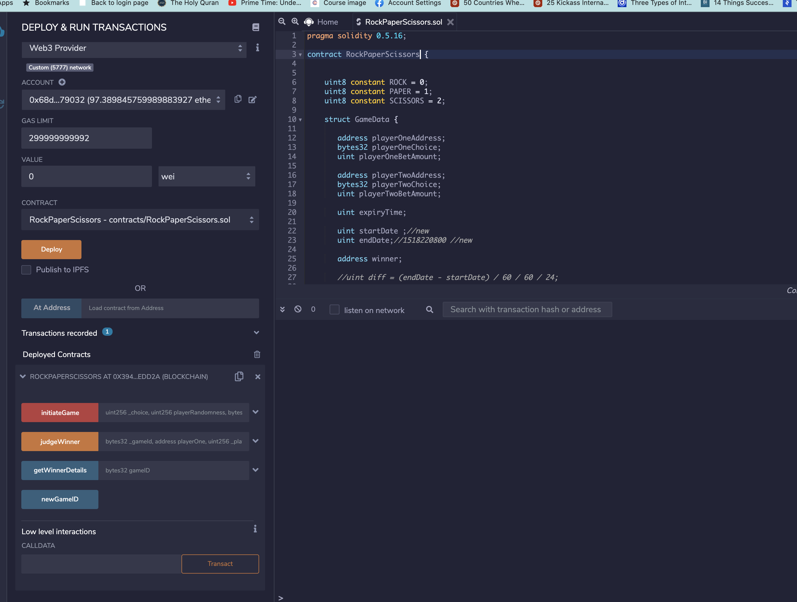

Initiate game:

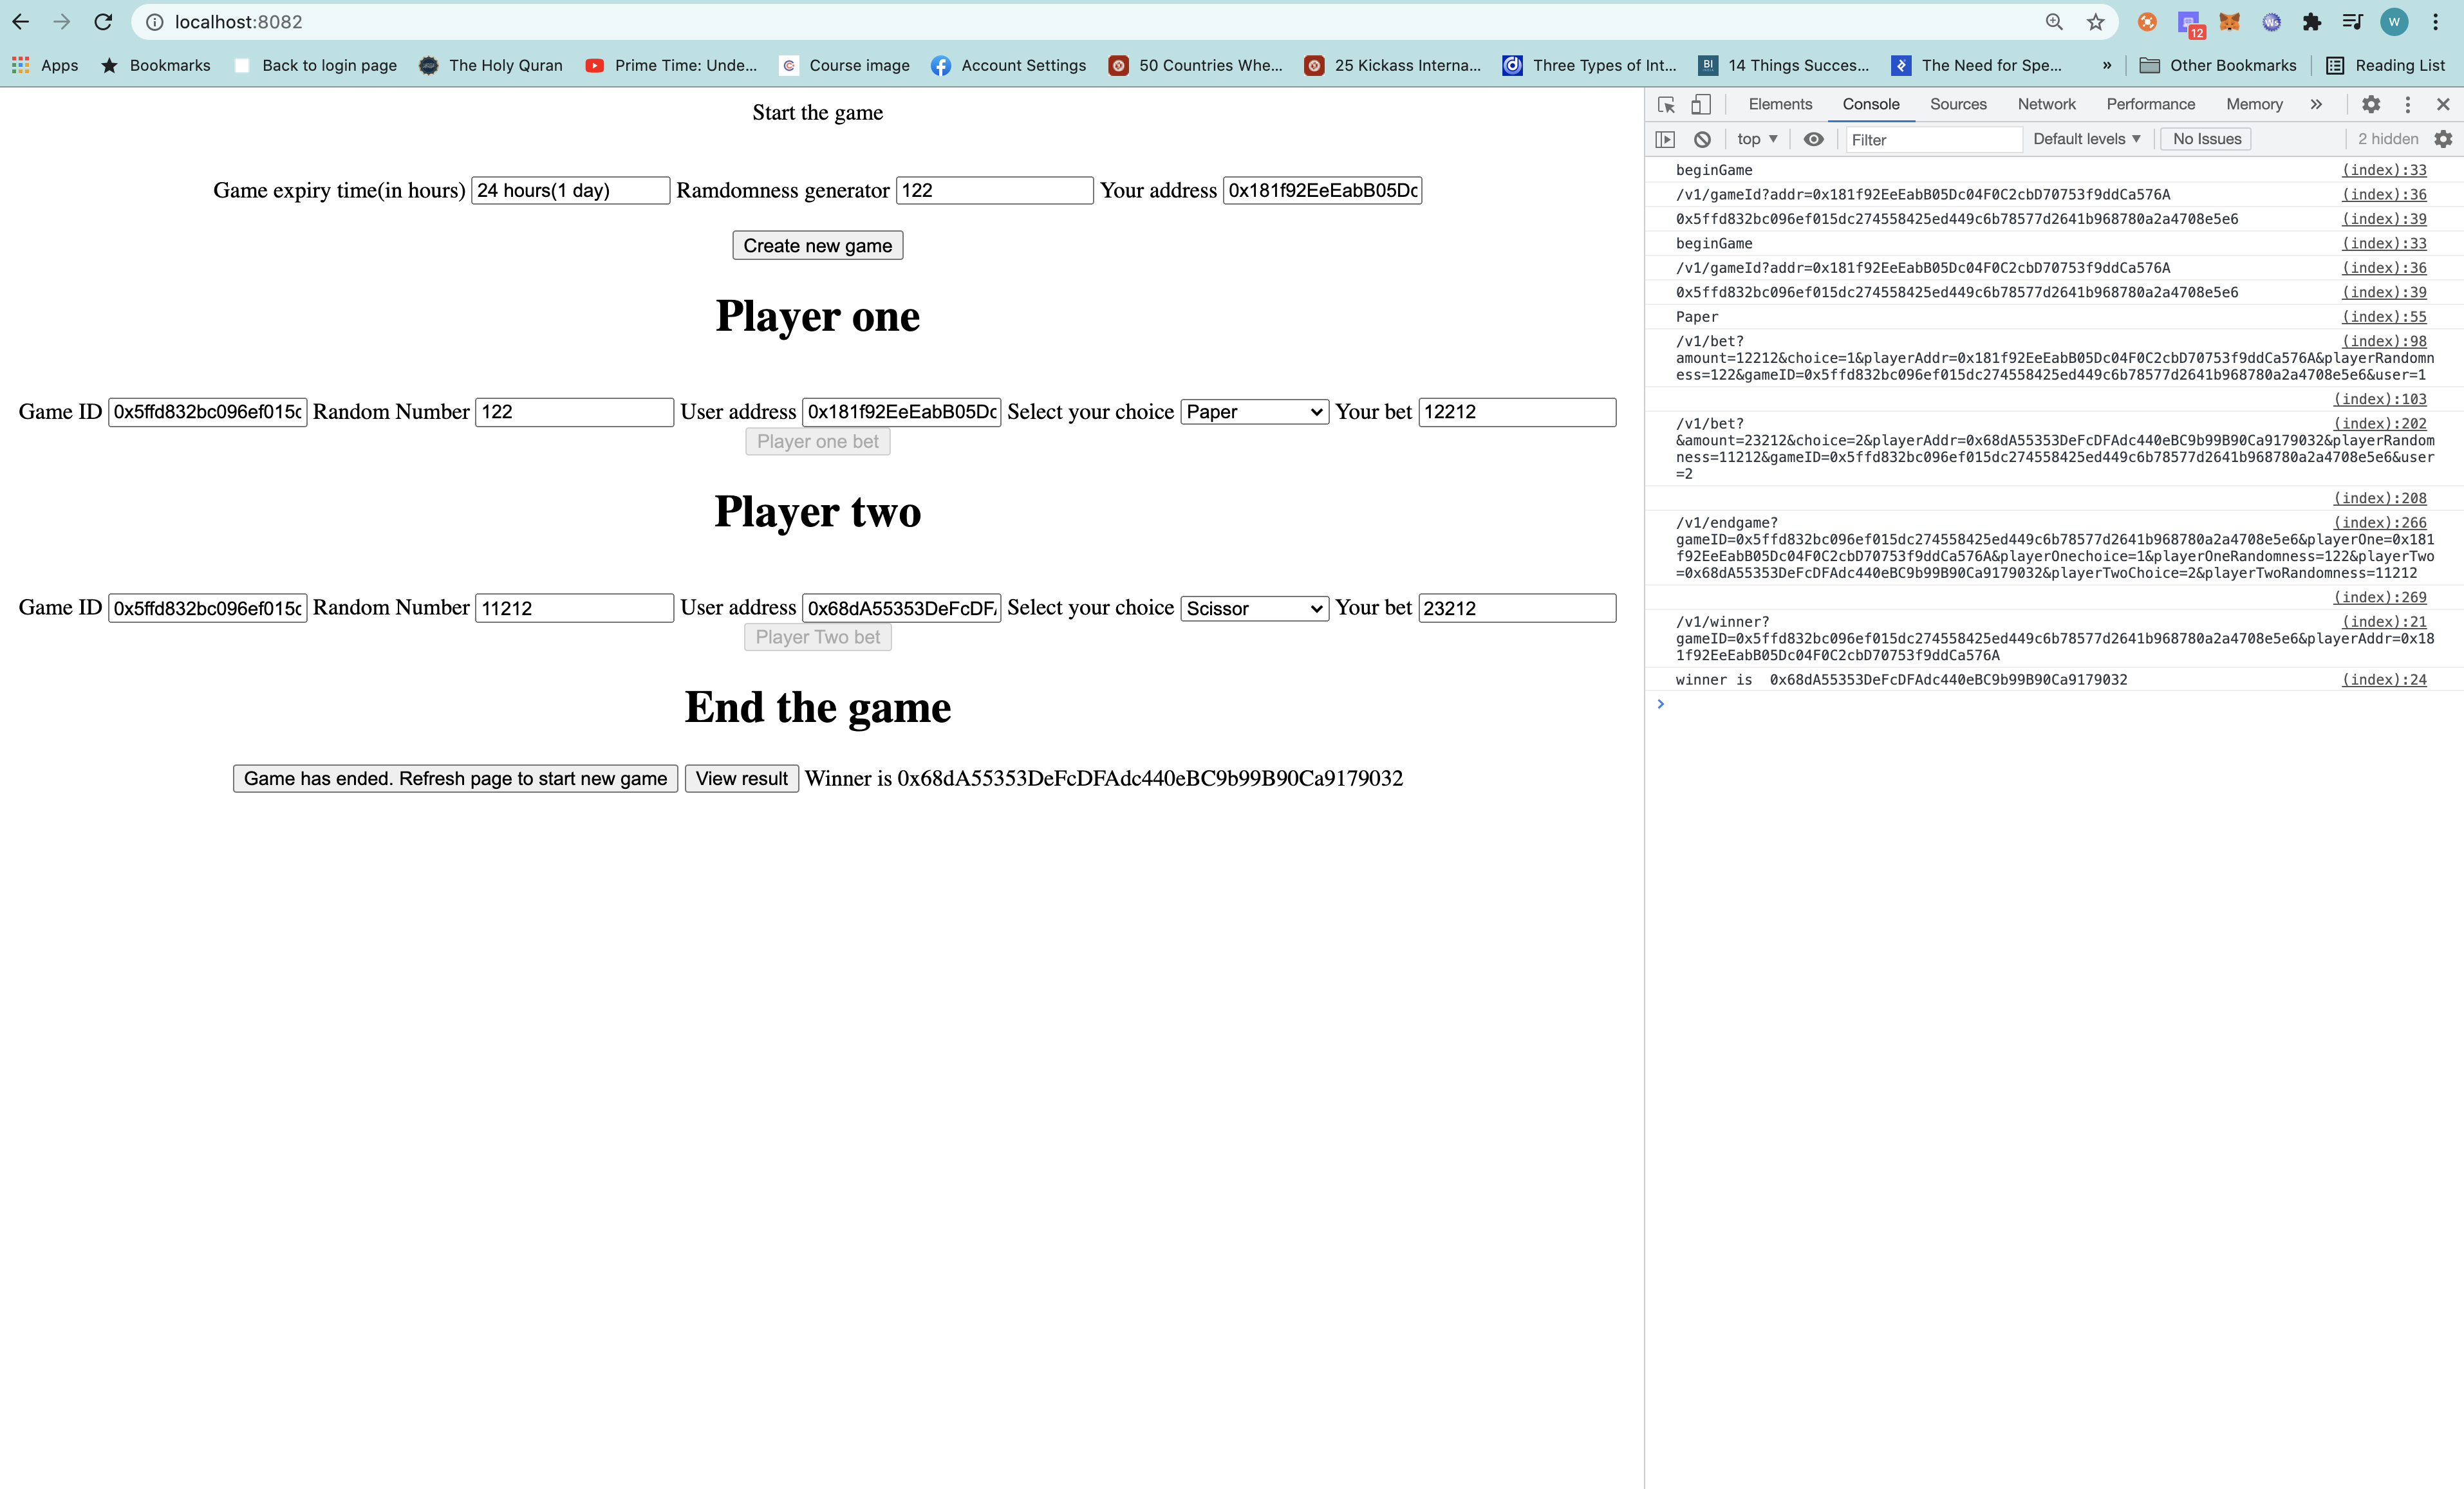

Smart contract execution [Remix IDE]

Deploying smart contract:

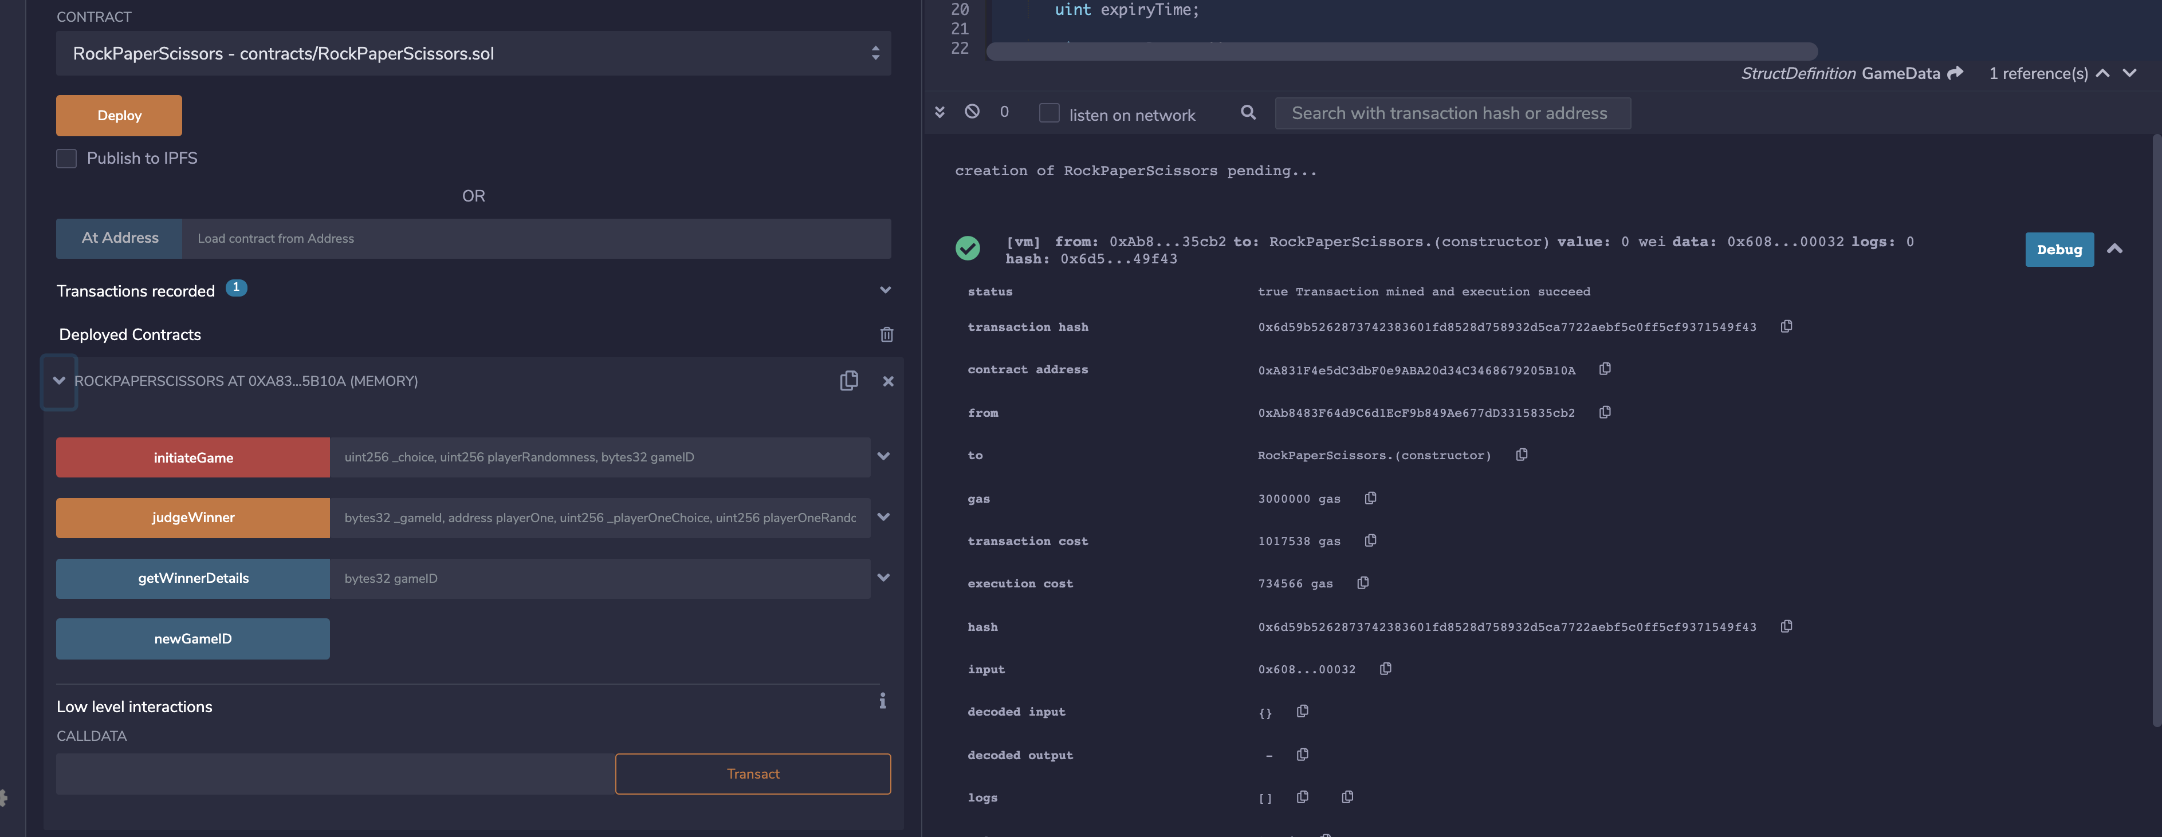

Starting game by generating the gameid:

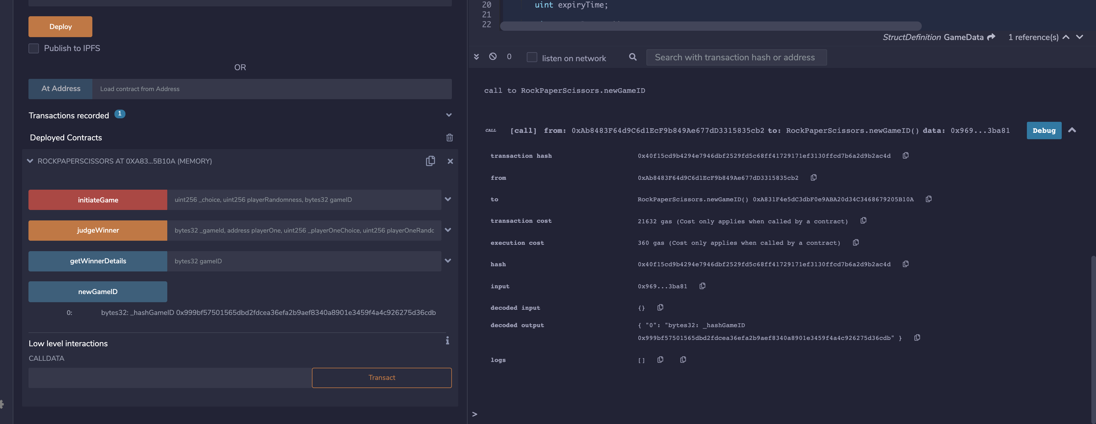

Placing bet:

**Player 1 addr 0xAb8483F64d9C6d1EcF9b849Ae677dD3315835cb2**

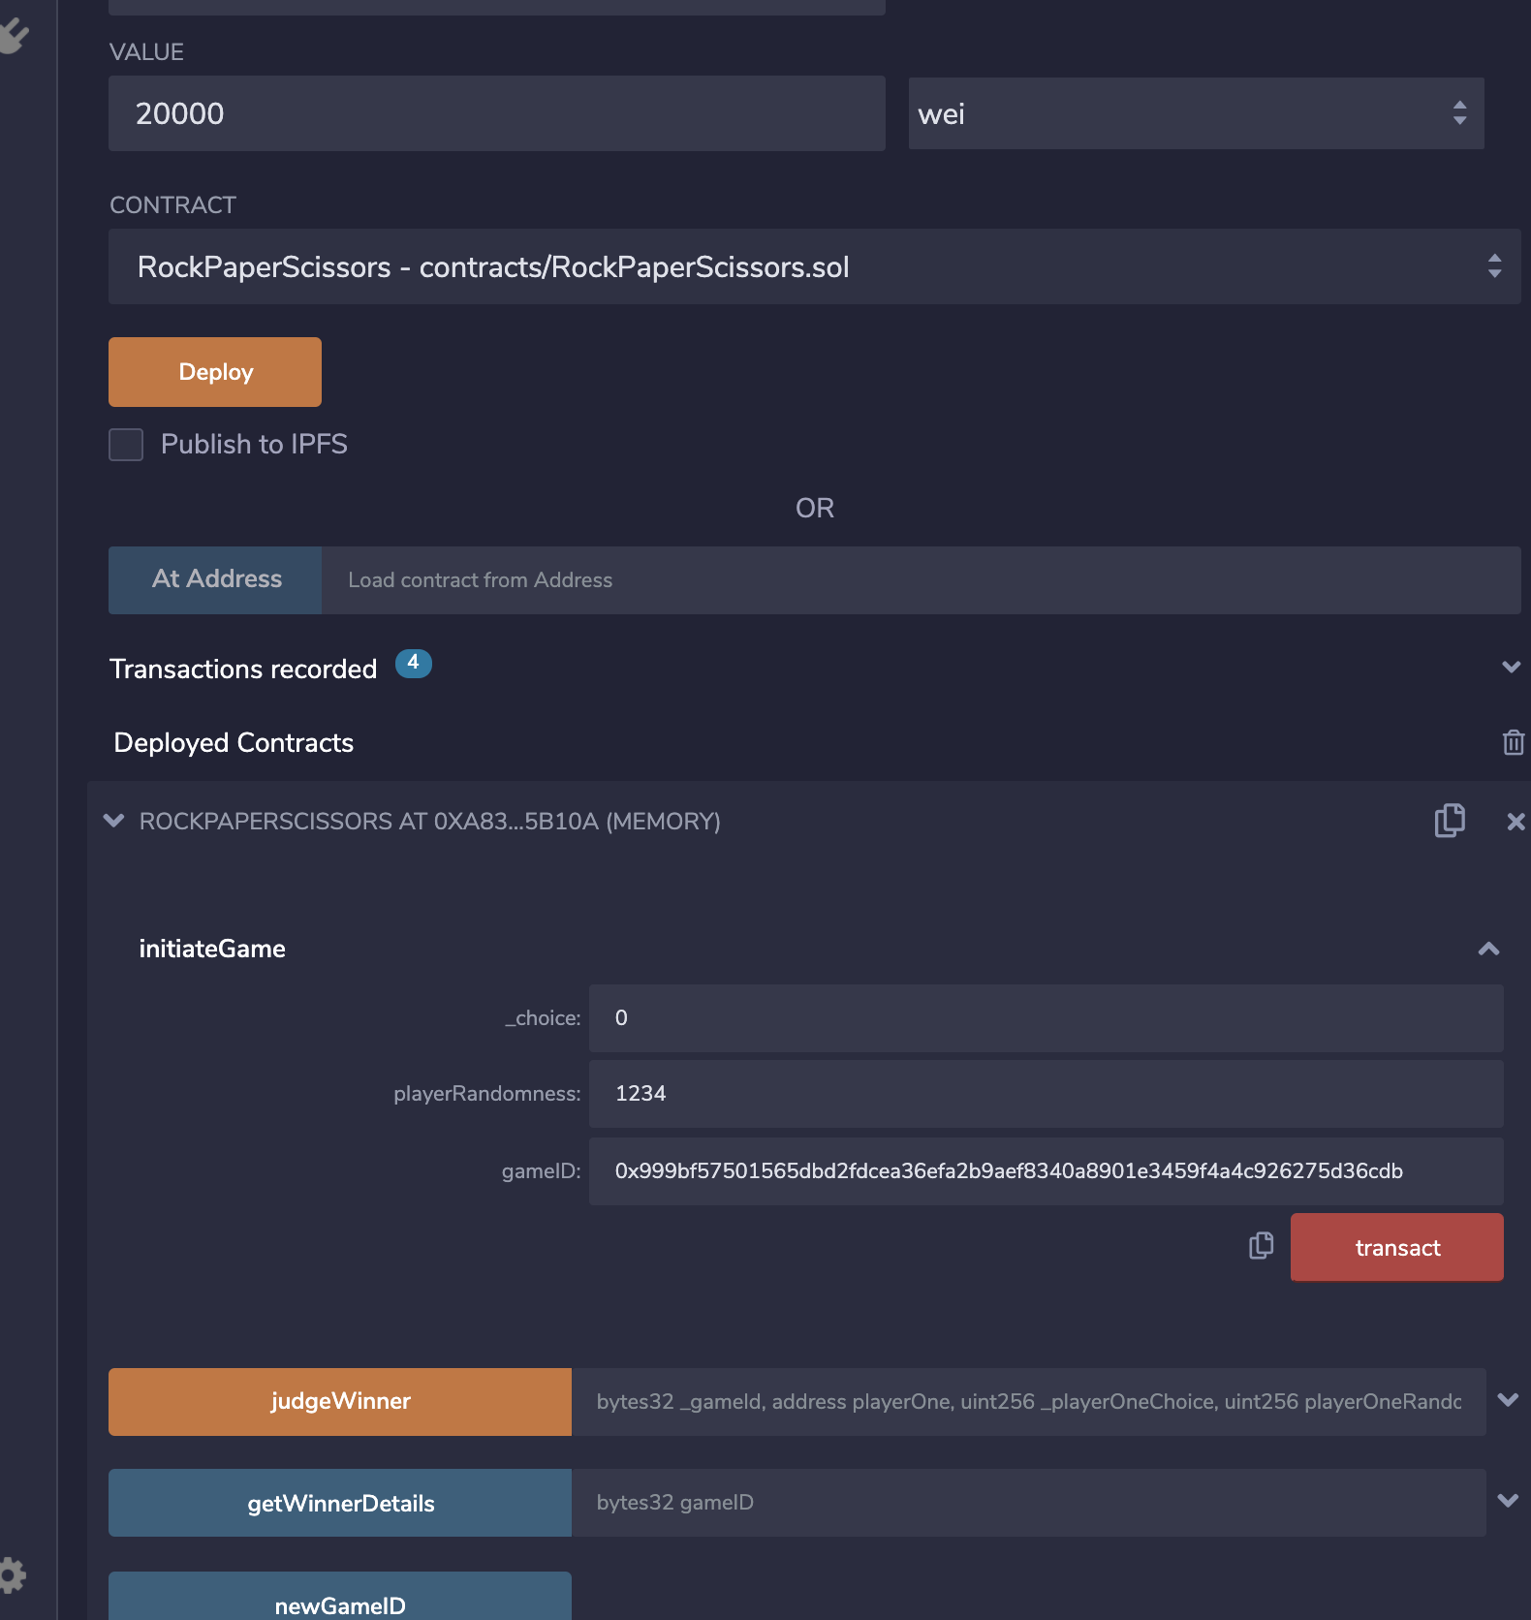

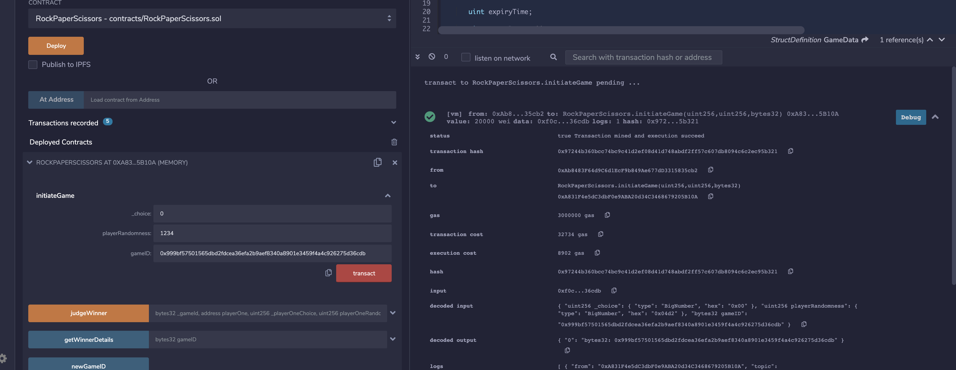

**Player 2 addr** : **0x4B20993Bc481177ec7E8f571ceCaE8A9e22C02db**

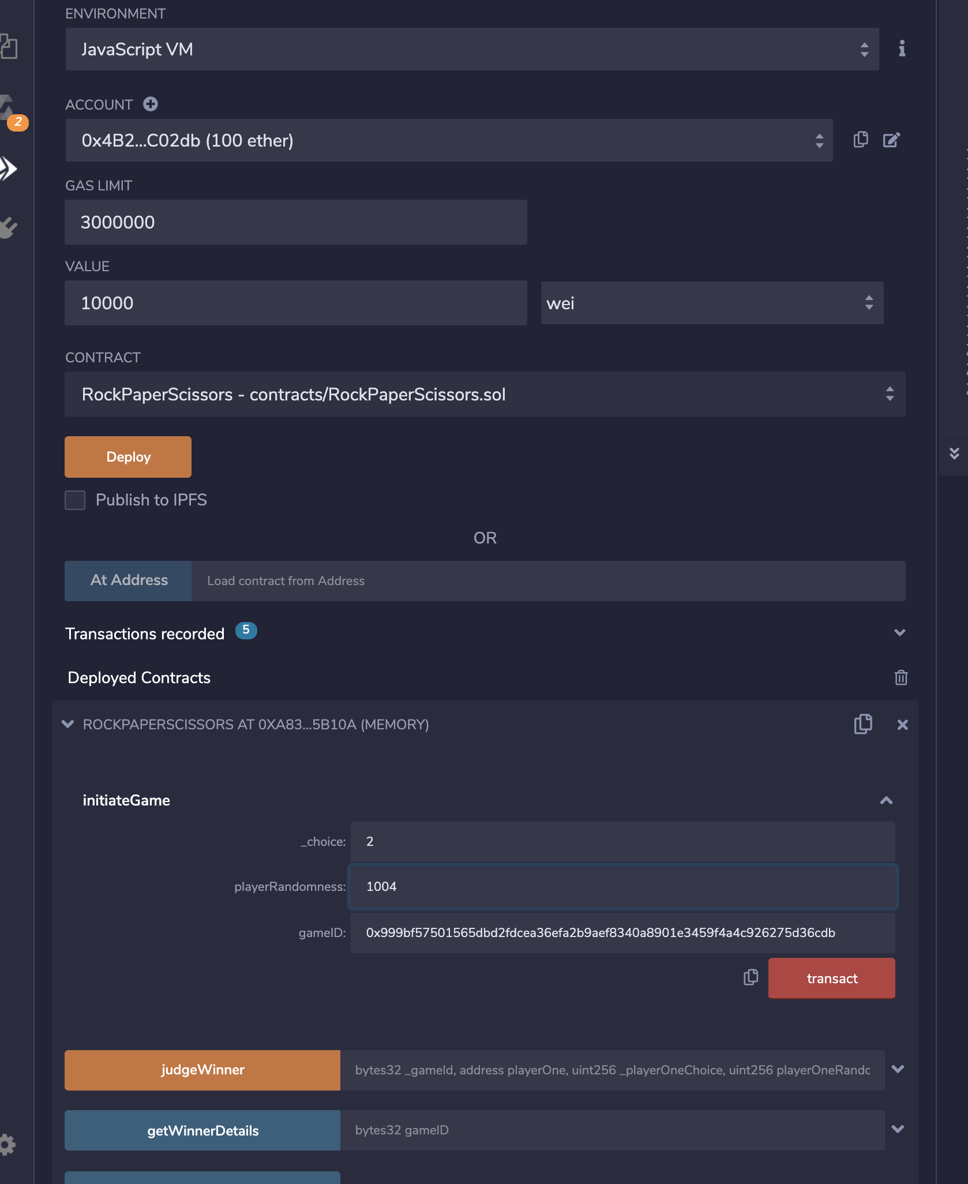

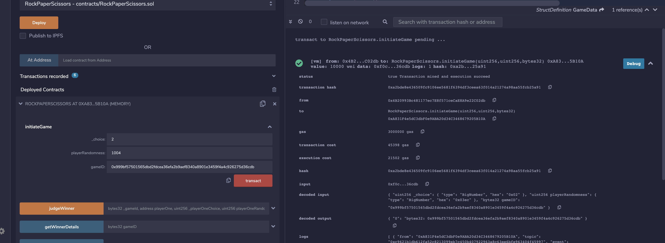

**End game:**

**When we end game from UI, ‘judgeWinner’ gets called.**

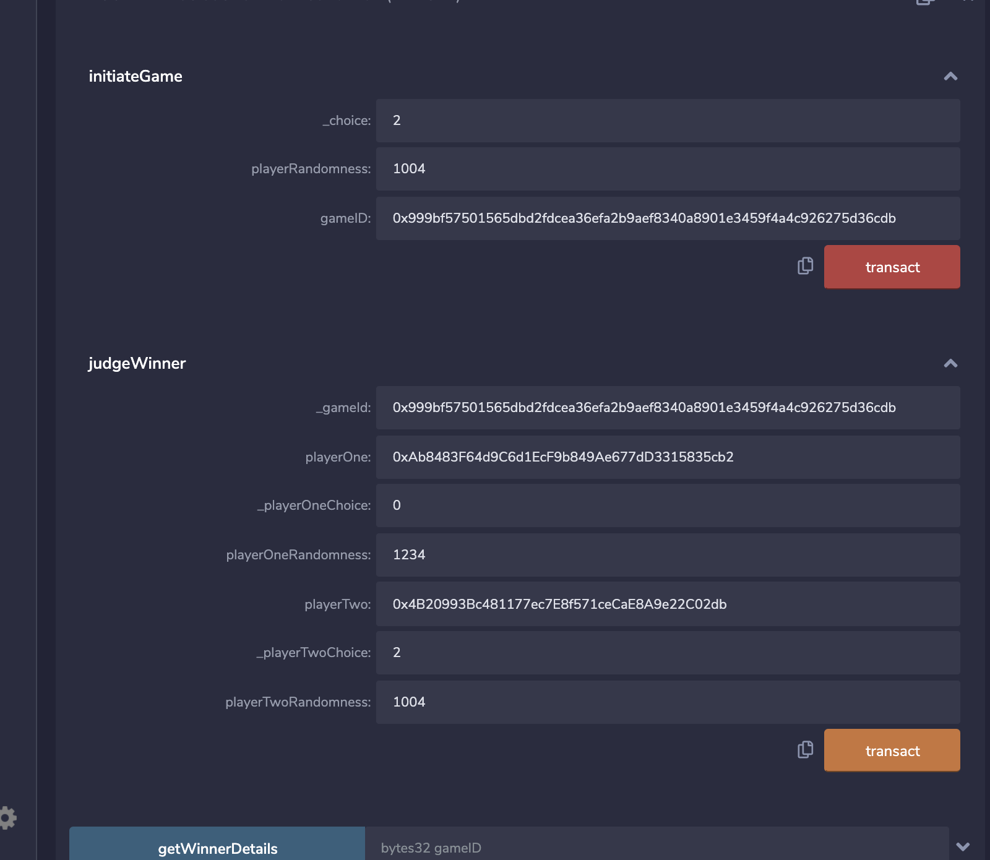

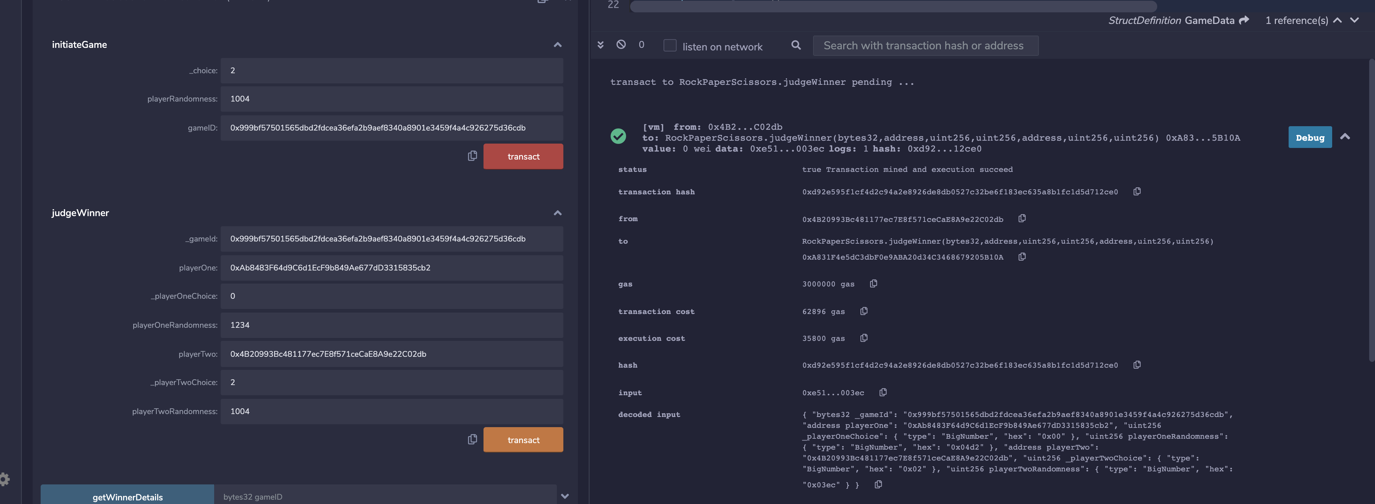

**View result:**

**When we clock on ‘View result’ game from UI, ‘judgeWinner’ gets called.**

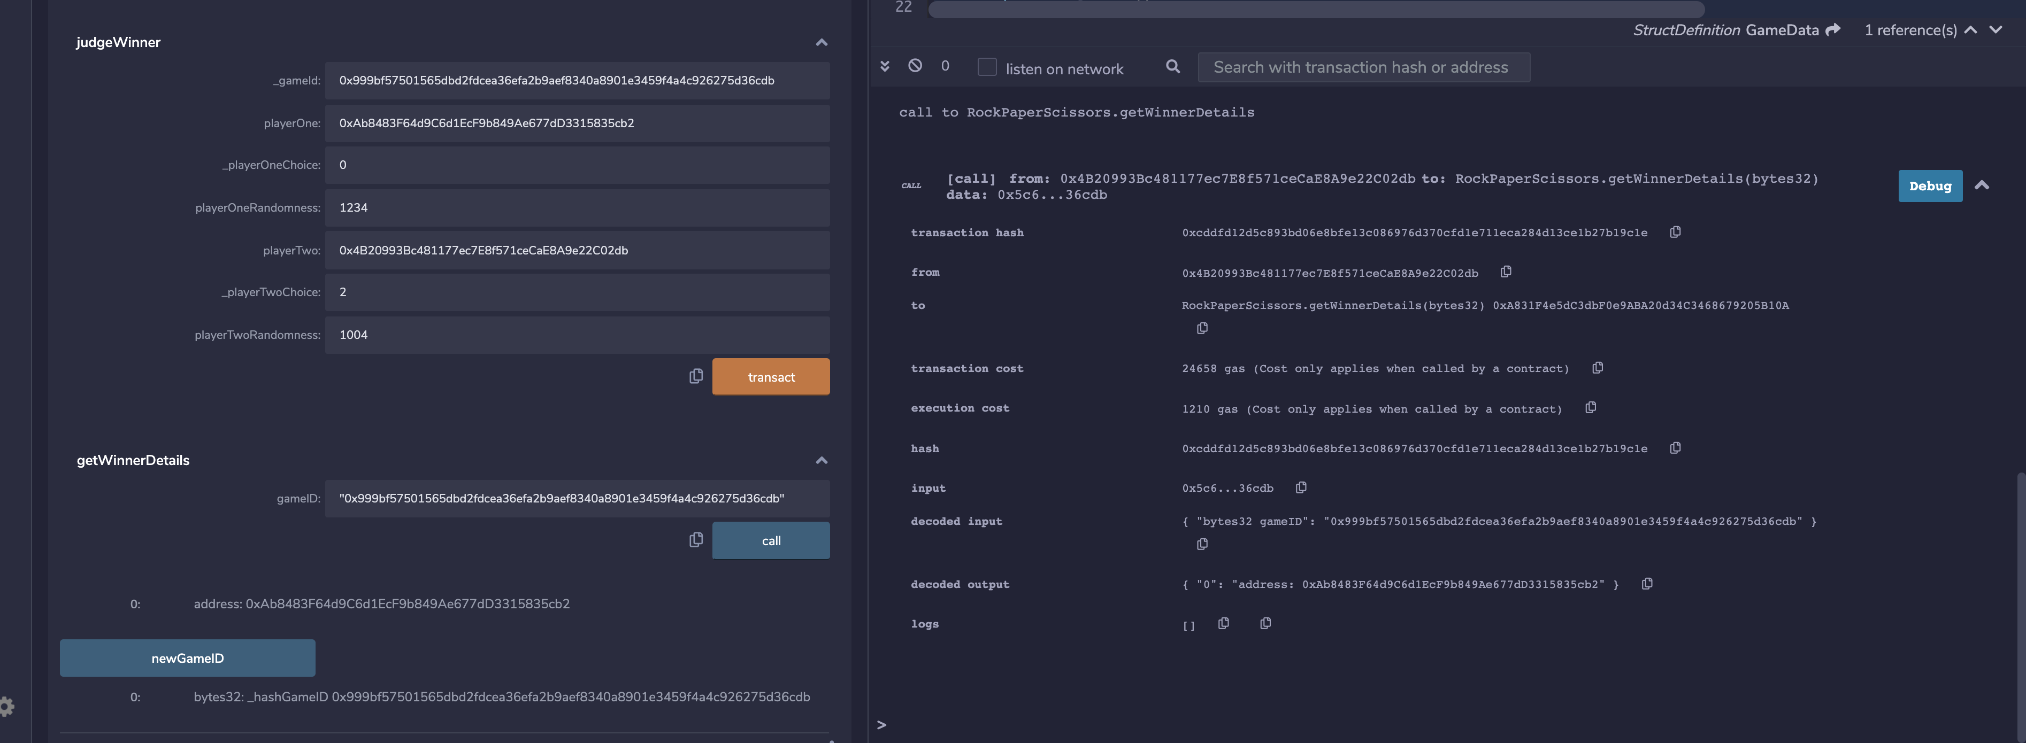

**UI Screenshots:**

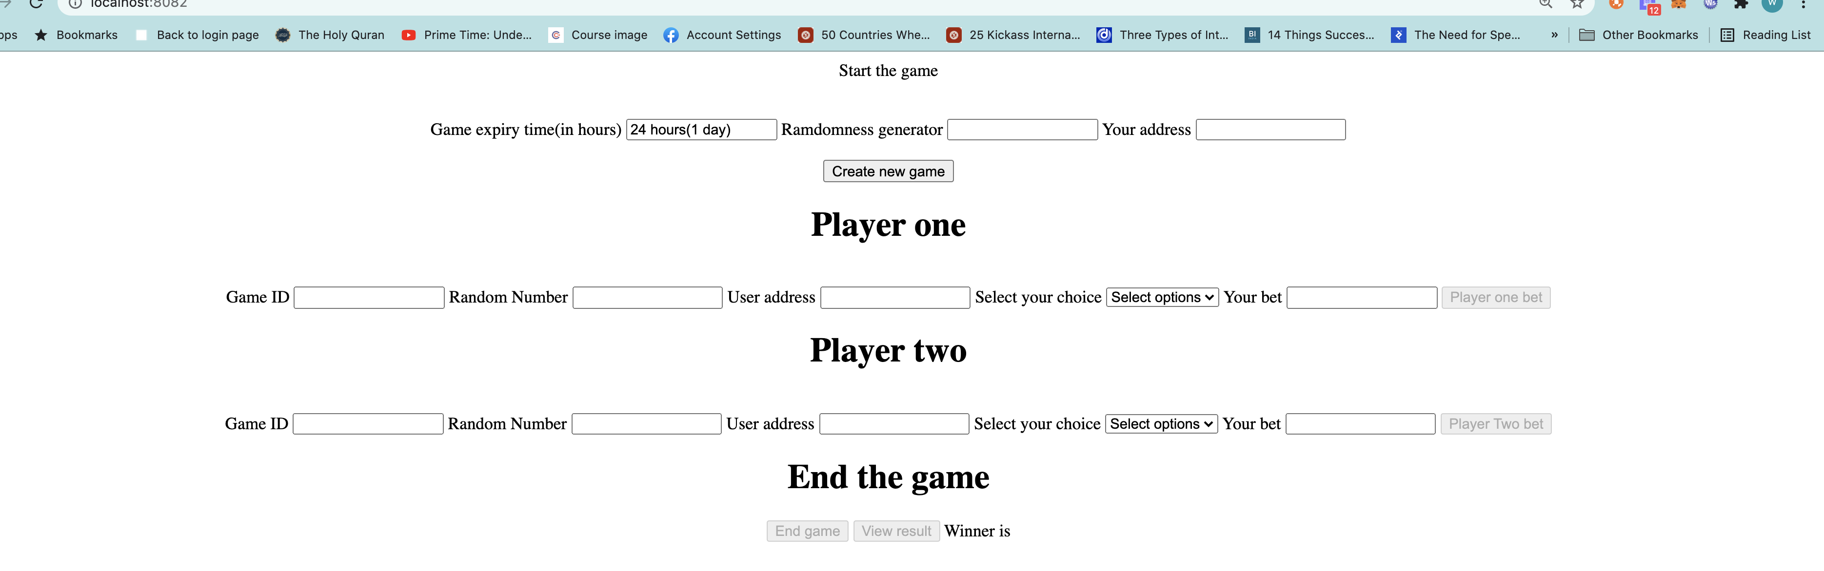

Player one initiated game by generating game id

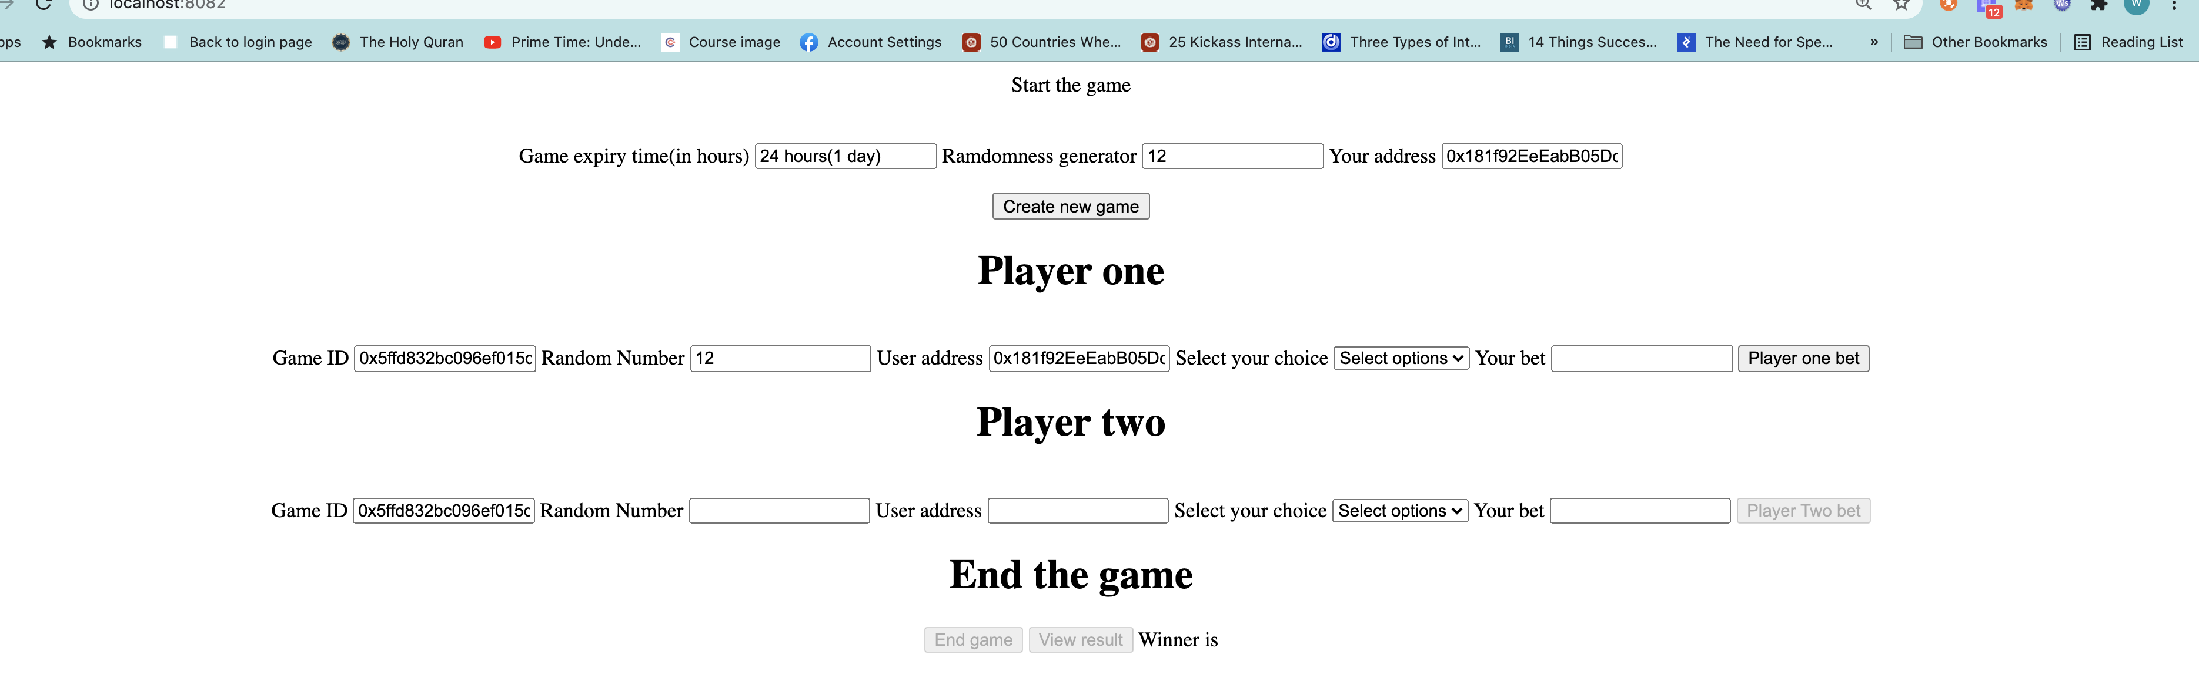

Player one placing bet :

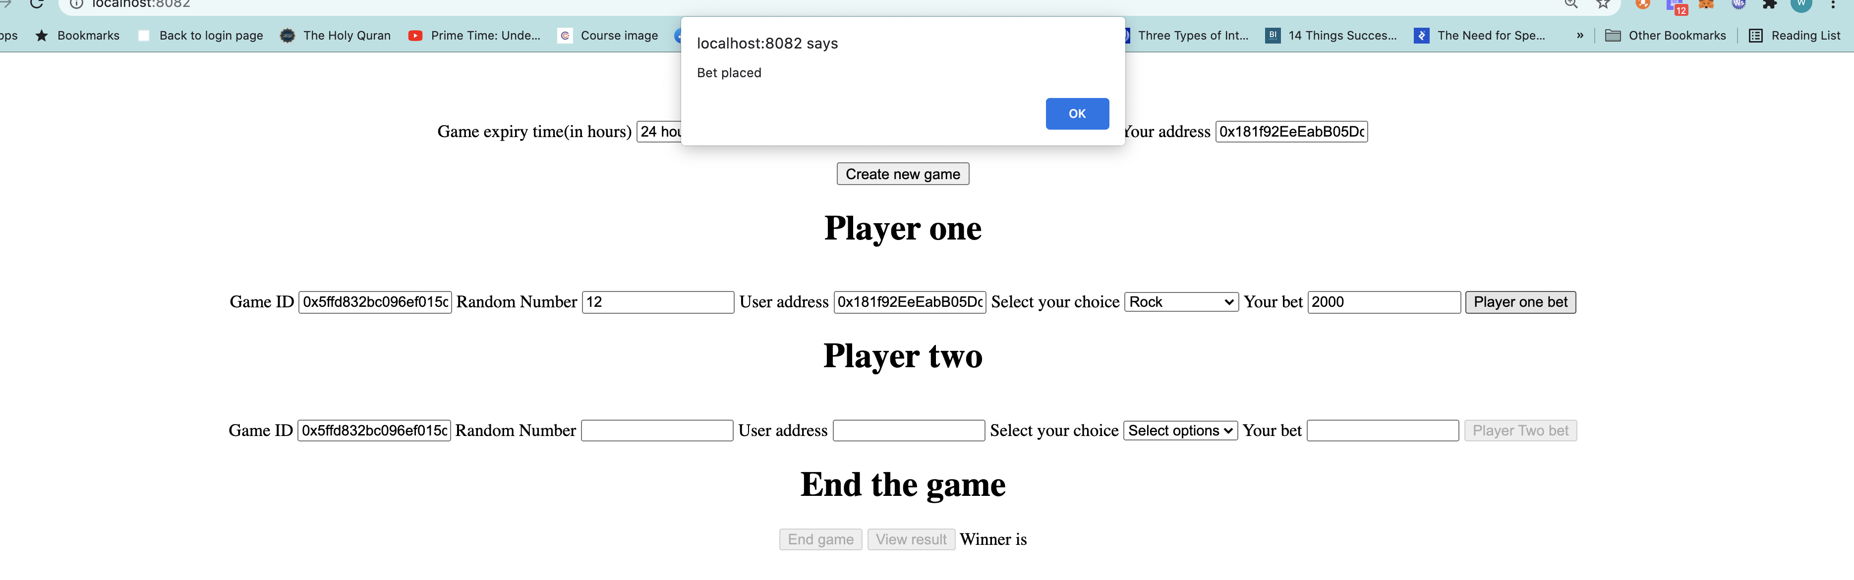

Console log

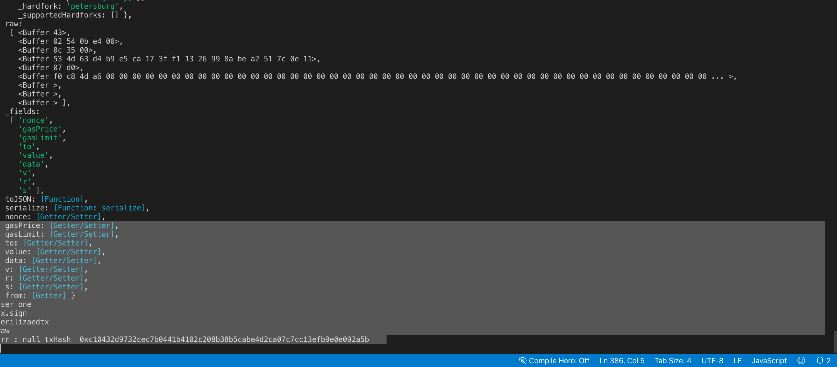

Player 2 placing bet

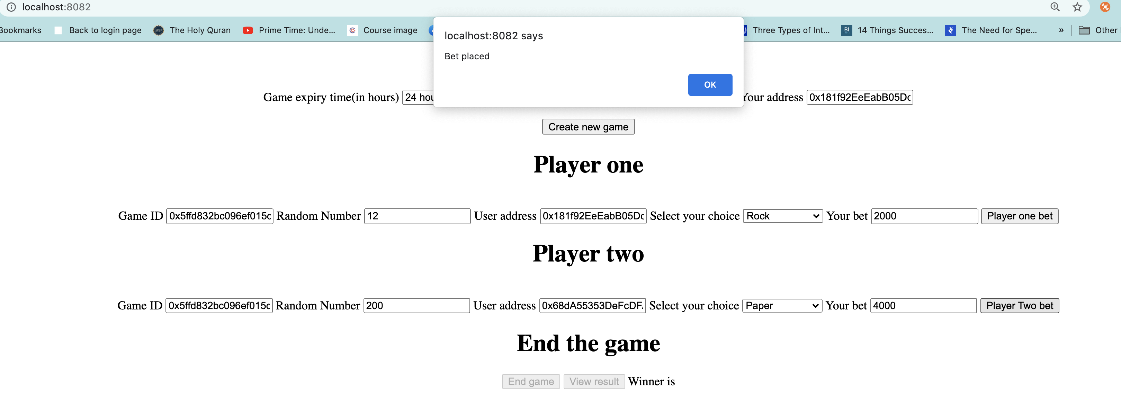

Console log

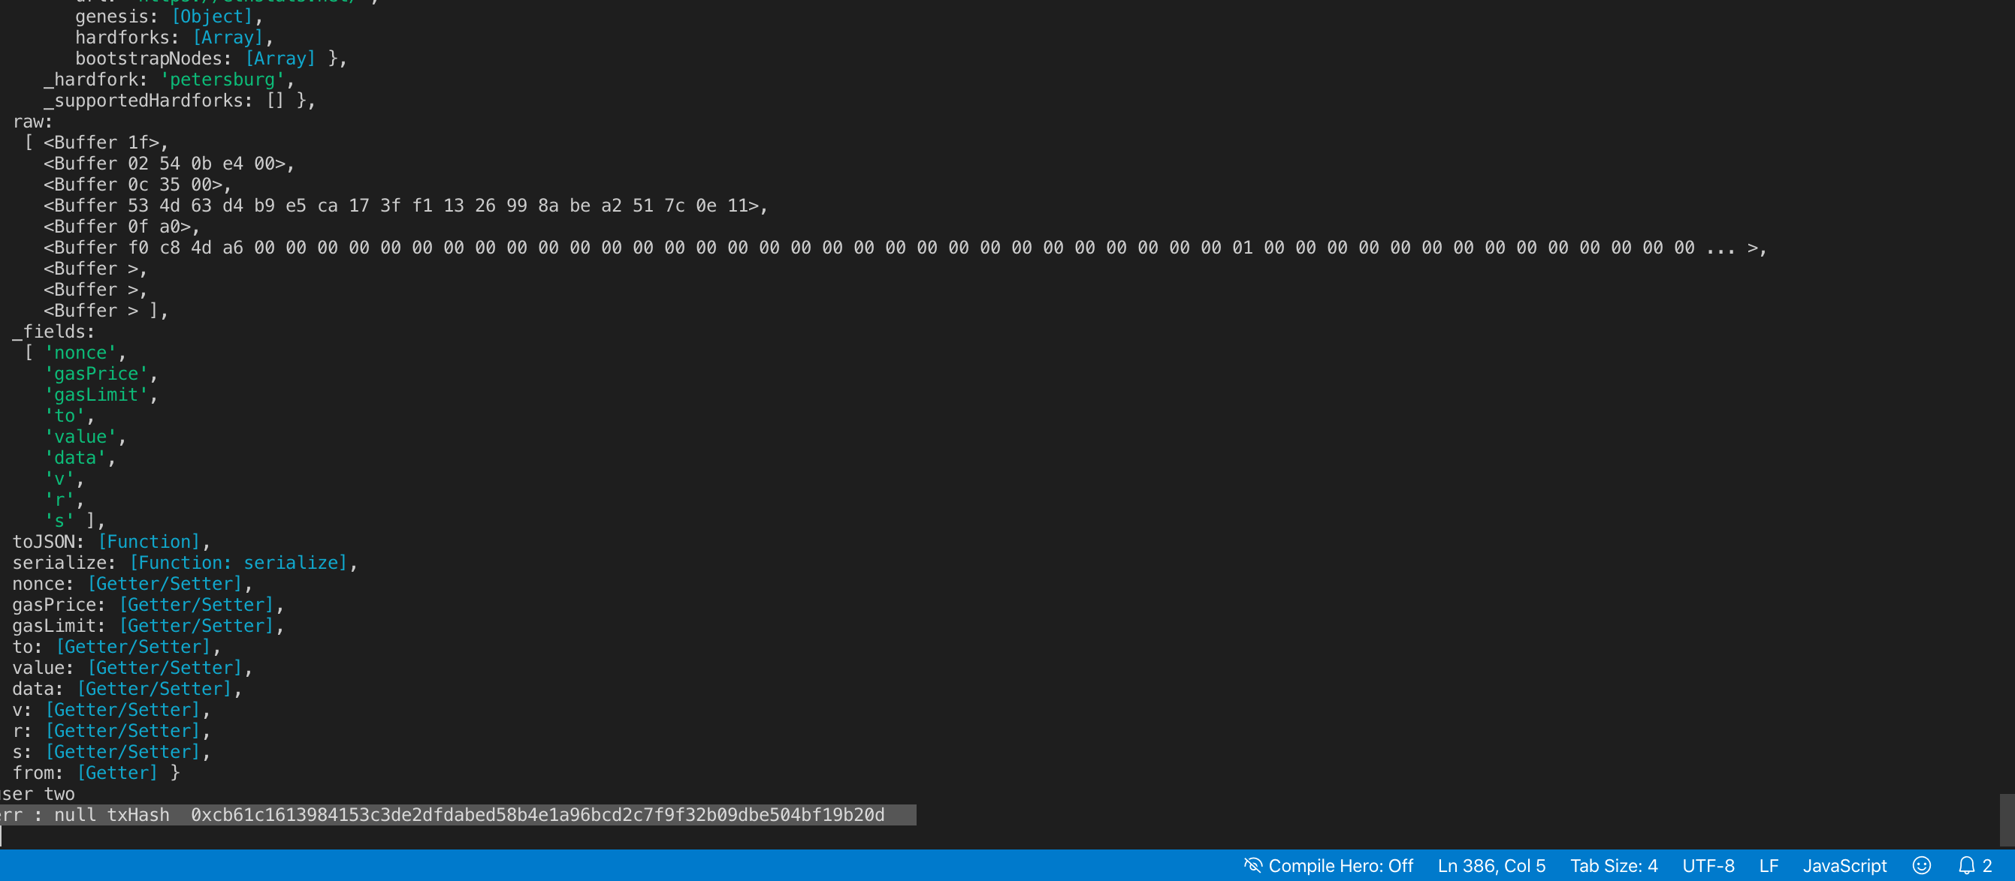

End game:

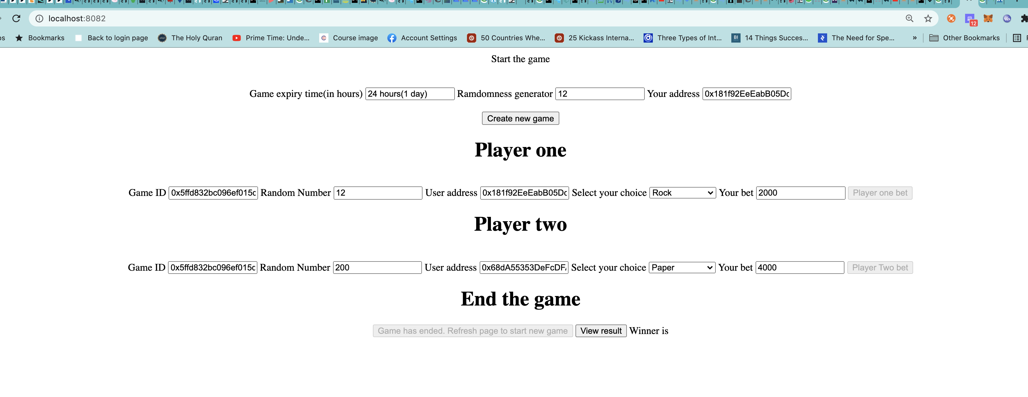

Console log

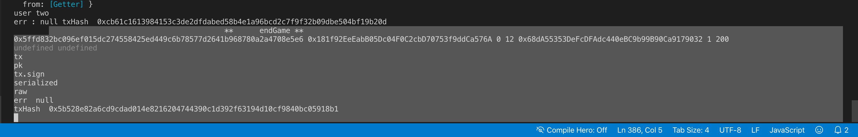

View result :

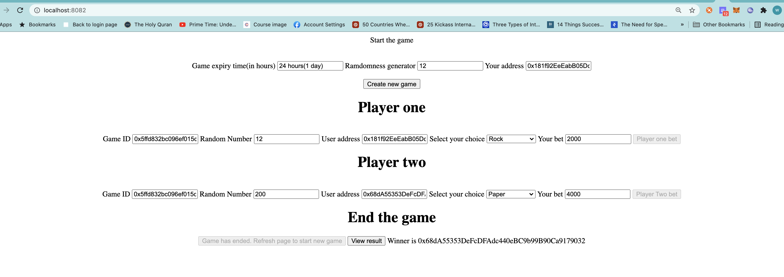

Console log [No log statements were put in method, but no error got logged.]

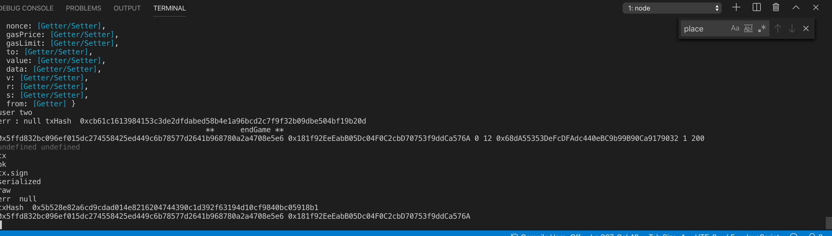

In case of Tie

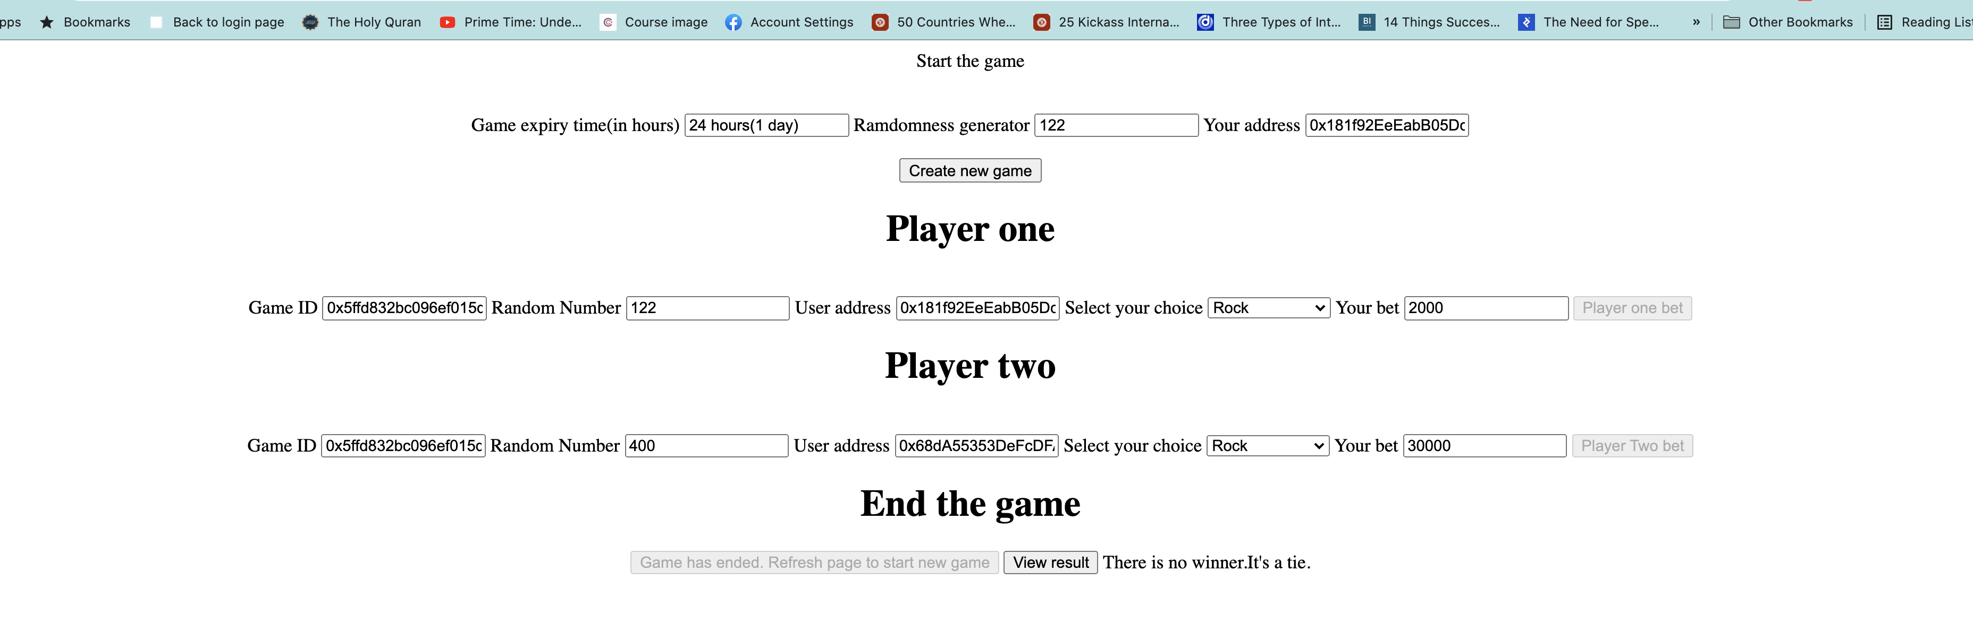

**Contract deployment on testnet[Ropsten]:**

Deployed contract address : 0x18A8c8C3c86ff0C6DFA71CD2a4dD976FbFabb21D

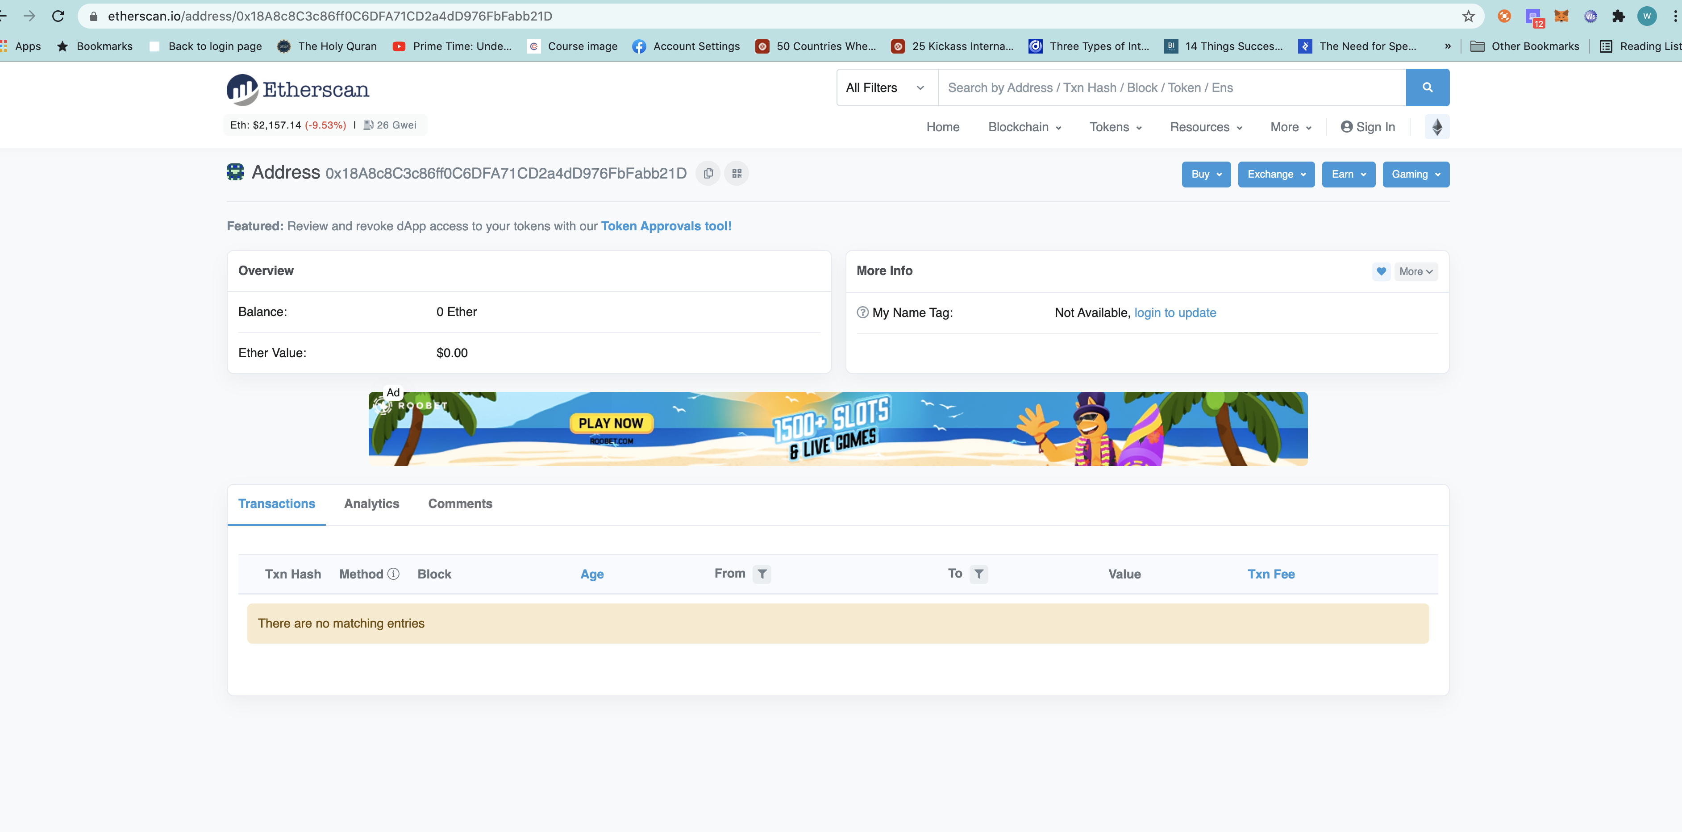

NOTE:

I have found out a bug in the code and have made code changes. Secondly, in the previous code when the contract balance is not enough to twice the bet amount of the winner, then no transfer was happening. Post change, now the amount equal to the bet amount will be transferred to the winner in case the contract does not have the enough balance to reward twice the bet amount to the winner as a transfer.

Updated contract address [Ropsten] : 0x534d63d4b9e5cA173fF11326998ABea2517C0E11

